Art No. 273
PN40 Brass HVAC Valve
Combo Strainer Valve
Features
- Working Medium: Water,
- Pipe thread to ANSI B1.20.1 NPT/ ISO228 /ISO7
- Solder Socket to ANSI B16.18
- A Combination Ball Valve, Strainer and Union
- Fixed end connection in FNPT or SWT or G or Rc
- Tail piece connection in MNPT,FNPT and SWT or G or Rc,Size Reduction Available
- Standard Features include adjustable Memory Stop and Pressure/Temperature Port, Plug and Drain Valve

202 IS

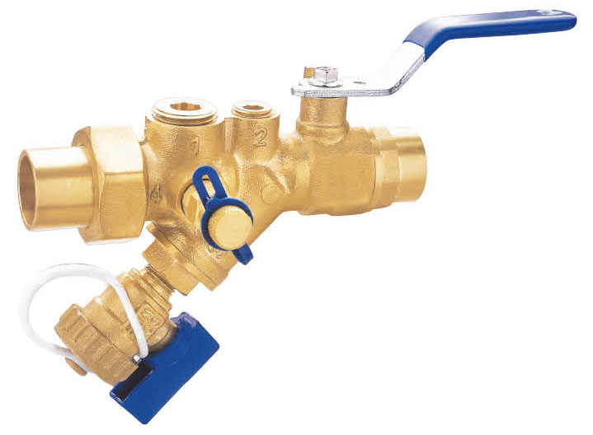

Technical Data
- Nominal Pressure：600WOG
- Working Temperature：-20℃～+110℃；
Material specifications
No. | Part Name | Materials
 | Body | Brass CW617N or DZR CZ132
 | Fixed End | Brass CW617N or DZR CZ132
 | Ball | Brass or DZR CZ132
 | Seat | PTFE
 | Stem | Brass CW617N or DZR CZ132
 | O-ring | EPDM
 | Tail Piece | Brass CW617N or DZR CZ132
 | Union Nut | Brass CW617N
 | Handle | Carbon Steel or Stainless steel 304
 | Hex Nut | Carbon Steel or Stainless steel 304
 | Memory Stop | Carbon Steel
 | Drain Valve | Brass CW617N
 | PT Valve | Brass CW617N
 | Strainer | S.S.304, 20Mesh

Dimensions for reference (in mm)
Size | 1/2” | 3/4” | 1” | 1 1/4” | 1 1/2” | 2”
L(FNPT) | 106 | 126 | 130 | 168.5 | 169 | 232
H | 50.3 | 53 | 53 | 62 | 62 | 79
D | 93 | 93 | 93 | 128 | 128 | 144
B | 15 | 20 | 25 | 32 | 40 | 49
E | 15.93 | 19 | 24 | 35 | 41.35 | 54.1

